Planetary   
 Defender

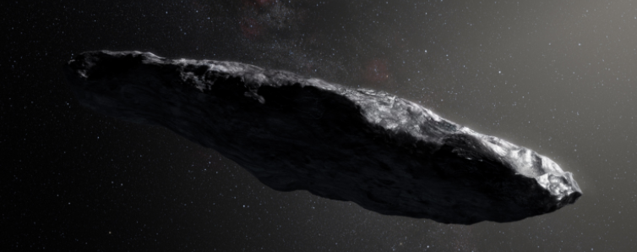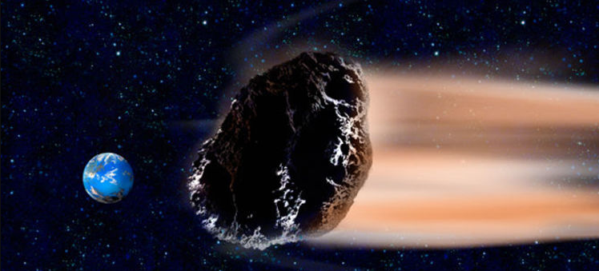

An alien ship arrives in the Solar System and causes an uproar on Earth. What are the alien’s intentions?

What does this mean for humanity? Are we safe?

The Alien’s next actions answers these questions when they proceed to start launching wave after wave of asteroids towards Earth.

Thankfully the large military budgets and paranoid leaders on Earth meant we had constructed an Orbital Defence cannon for just such an eventuality.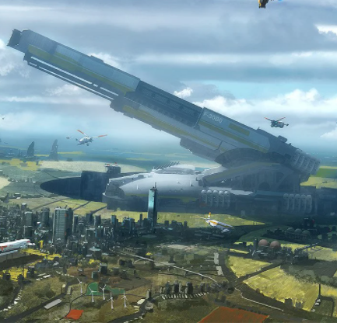

When it was being constructed, it was found during research by the military that PC gamers had the ideal skill set necessary to operate the cannon at peak efficiency. You had been headhunted earlier and had quickly risen through the ranks of the other applicants to be the lead candidate.

Now is the point in time to prove to everyone that you can defend the planet from the asteroid onslaught.

Earth needs time to develop a more permanent shield technology before the Aliens decide to attack directly with their ship.



The game starts with a high level view of the space around Earth, up to and including the Moon. The view is framed with half of the Earth visible and the Moon in an upper corner.

A turret can be seen on the visible part of Earth. Asteroids will spawn off screen on a collision course with Earth and it is up to the Player to swivel the turret with the mouse and shoot the Asteroids before they impact into the Earth.

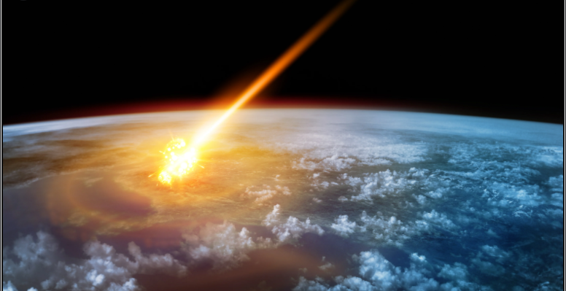

‘PowerUps’ will randomly spawn on the screen and can be claimed by shooting them with the turret.

If the Player destroys all the Asteroids or 60 seconds elapses, a congratulations message shows and the next level begins - with an increase in the quantity of Asteroids.

The main character of the game has to be the Planetary Defense Cannon.

Powerful enough to launch projectiles deep into space and agile enough to adapt to rapidly changing combat situations.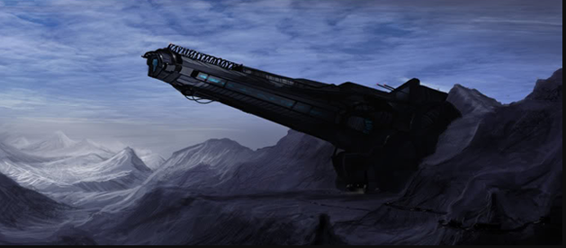

The PDC is installed into a large mountain range to absorb the recoil generated during use.

It sticks high up into the atmosphere and has a large cache of ammunition stored away.

The Player is a ‘Gamer’ that has been chosen after a grueling vetting process to find the best of the best. They operate the cannon using a simple mouse control and get input on incoming objects from Deep Space Radar and various other early warning stations situated throughout the Milky Way.

There is an element of desperation in the game - if the Player doesn’t eliminate all incoming Asteroids then an Extinction Level event will occur on Earth.

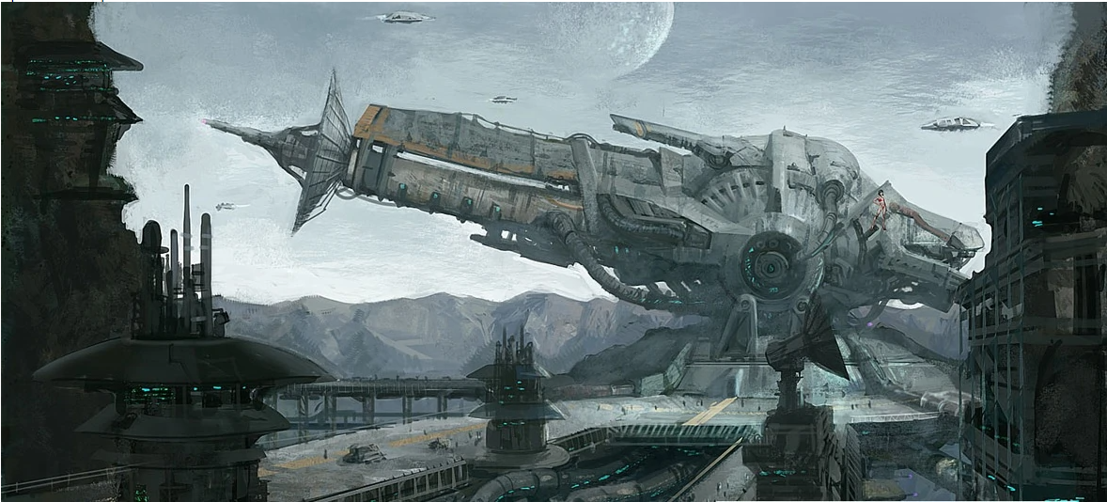

The Incoming Objects Display shows the Asteroids as they enter PDC range. It gives the Player a detached connection to the action - they’re not literally holding the gun that shoots the Asteroids, it all happens from a clinical distance.



The turret firing will be triggered using the left mouse button. There is the potential to add additional uses for the right mouse button as well - depending on the scope of the game.

The turret is upgradable, the firing speed and speed/size of the projectile can be changed. This is done by shooting ‘Power Ups’ that spawn randomly.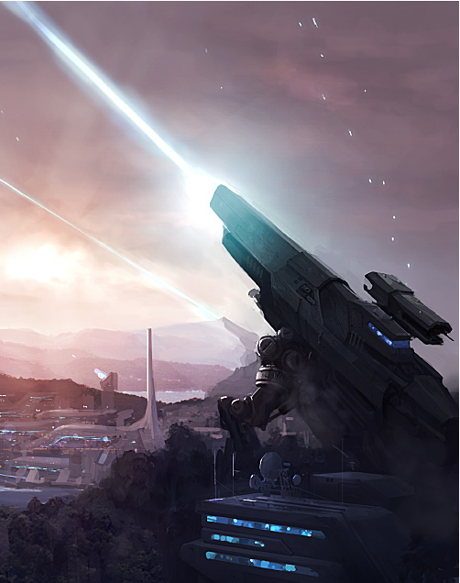

It also swivels quickly based on the Player’s mouse movements. This gives it more of an arcade style feel. It also starts with a relatively fast firing speed, to promote the feeling of pressure and speed, during the planetary defense combat situation.



The Gameplay will be very arcade in style. The Player will be dropped straight into the combat situation with very little background given. 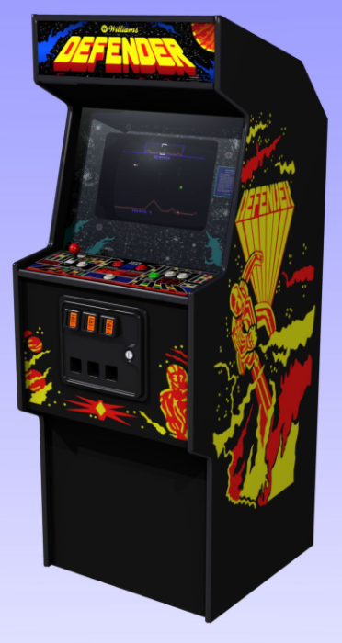

There will be a very simple uncomplicated level structure, just the planet Earth, the Moon and some incoming Asteroids. The main ‘laser-focus’ should be on the incoming Asteroids for the Player.

The variable part of the game will be the quantity and speed of the Asteroids. This will be used to create distinct ‘levels’ of difficulty. Possible Changes include;

* Tougher Asteroids that require more shots to destroy.
* Asteroids that split into multiple smaller ones when they explode.
* A small Alien ship that attempts to ‘shield’ the Asteroids.
* Smart Asteroids that use Alien Technology to partially dodge Players shots.
* Stealth Asteroids that are harder to see when incoming.
* Asteroids that push out with explosive force when destroyed, disrupting the line of shot to neighbouring Asteroids.

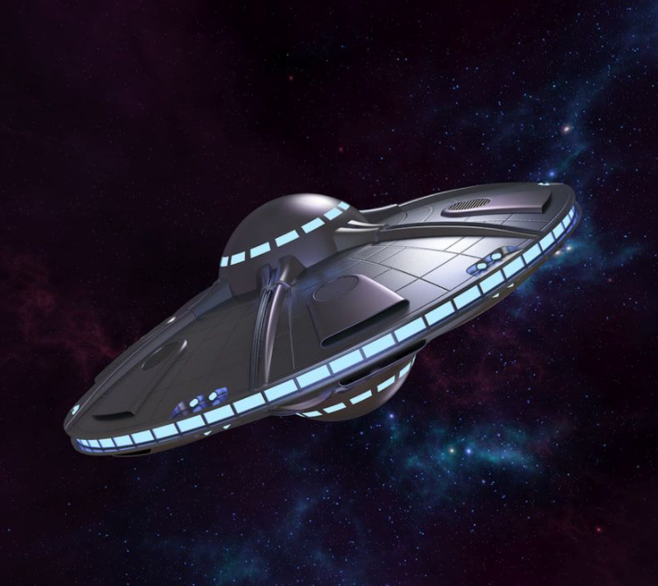

Every five levels the Alien invaders will change their strategy slightly and the Player will need to adapt for the next five levels.

Eventually the Alien spaceship itself will attack Earth as a ‘Boss Fight’ and the Player will need to utilise all the skills they have built up to defeat this final challenge.



The game will have high tempo background music to complement and match the frantic nature of the situation and gameplay. The pitch of the music can be increased as the speed and quantity of the Asteroids increases. Ideally something with a strong beat to encourage the Players heartbeat to match and set the frantic tone for the game.

The gameplay premise and look will be familiar to older gamers and should give a feeling of nostalgia when playing.

The bullets from the turret and the Asteroids will be governed by the physics system and move according to the gravity well of the Moon and the Earth.

The game will initially be released on the PC but the controls could easily be adapted to any console or mobile platform.

The game world is set in the local space around planet Earth.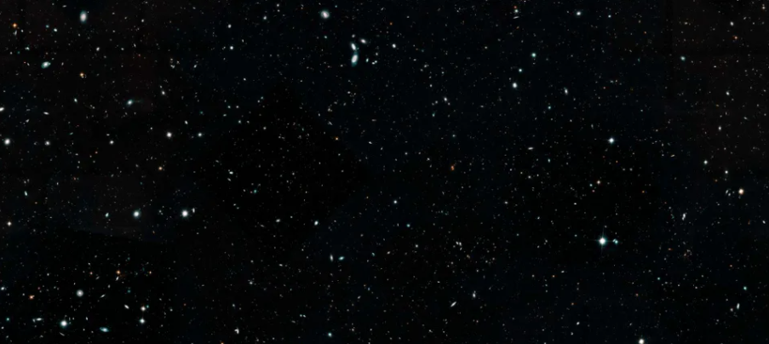

It is deliberately left mostly empty to give the impression of the vast void-like nature of space.

The Player gets a small glimpse of a very vulnerable planet Earth at the very bottom of the screen. They see that the turret they are operating is the only thing stopping the incoming Asteroids.



The fast tempo music will set the scene of a combat situation, frantic and desperate defense of Earth. It will be deliberately jarring when compared to the cold emptiness of space. It is the human element that we bring with us for inspiration.

Potentially in the later levels, the Moon gets destroyed and creates a shower of fragments that the player has to quickly destroy.

The aim being to catch the Player off guard, as the Moon has stalwartly blocked incoming Asteroids up until that point.



The Game Experience will be geared towards creating the feeling of clean advanced technology. Menu and popup borders will be crisp and cool in colour temperatures - either blues or blacks.



The turret will give a satisfying thud as it fires and the bullet impacts will do the same when they impact with anything. This gives a feeling of power towards the piece of equipment the Player has been given to defend the Earth.

The feeling of being in a secure, but still dangerous bunker is reinforced with the hazard striping on the menu. It also helps to universally convey danger to the Player.



The menu will have a rotating clip of the Earth, to remind the Player what they are trying to defend.

A robotic voice announces “ALLERRRT…” when the initial popup appears, describing how to play the game. This reinforces the futuristic nature of the situation.

The announcement when passing or losing a level also uses the same robotic voice to keep consistency.

The font used was chosen for similar reasons, to give a futuristic but also distant vibe.



The interface is deliberately kept simple to enable the Player to jump quickly into the game and to rapidly get the information they need during gameplay.

It also helps to reinforce the futuristic and clean feeling we are going for.

The Player will have the story, game rules and controls explained to them through information popups at the start of the first level. This keeps with the cold, clinical vibe we are going for - similar to what you would get from a military AI overseeing the Player’s actions.

As Power Ups are collected, the firing speed and/or speed/size of the projectiles will be increased. This gives the Player a feeling of increasing power that synergizes with the frantic defense nature of the gameplay very nicely. The increases from Power Ups will be carried over between levels, giving a feeling of ownership/progression to the Player as they move through the game.

Gameplay Mechanics that exist for the game include physics based projectile paths. As a bullet or Asteroid nears an entity with a gravity well, it’ll have its path curved towards the entity.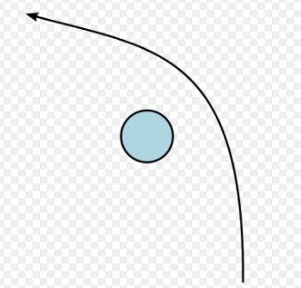

This makes it harder to estimate where a particular moving element will be, especially in a frantic combat situation.

There will also be a number of Power Ups that spawn randomly in the game level. These will start off being all positive in nature but gradually negative ones will also be included.

Power Ups include:

An increase in firepower - making the bullets travel with a higher velocity and with an increased size. The bullet velocity helps the Player by letting them not have to estimate so much where the final position of the Asteroid will be once the bullet arrives. 

The bigger projectile size helps in impact with Asteroids, even when the shot wasn’t necessarily direct-on with the Asteroids’ path.



An increase in firing speed - enabling the Player to fire more bullets per second and creating more bullets to hit with anything incoming. This Power Up is especially helpful, as it allows the Player to ‘fill’ the area with bullets and allows them to shift their attention to other areas that require more dedicated focus



Computer Malfunction - controls are reversed or buttons are changed. Graphics glitches may appear on the screen, blocking the Players view of the game content. These effects wear off after a computer ‘reboot’



Mechanical Malfunction - something in the physical workings of the turret breaks. This causes the turret to turn slowly, potentially ‘stick’ in one place, or have a reduced rate of fire until the support team can fix the problem.

The main enemy for the game will be the incoming Asteroids. They represent the implacable force careening towards the planet and they must be stopped.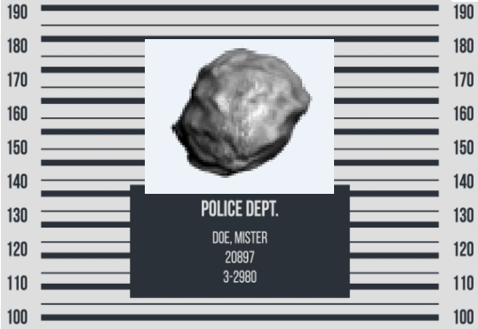

They are deliberately blank objects without personality or motives. The Asteroids are just the tools/weapons of the Aliens intent on destroying life on Earth.

As the levels progress, the characteristics of the Asteroids are changed by the Aliens, as they probe our defenses, looking for weak points.

The speed of the Asteroids increases as well as the quantity incoming during each round.



The only other enemies in the game are the Aliens themselves. Their motives are never explained, they just arrive and launch an immediate attack on Earth. That makes it even more menacing in nature - there is never any negotiation or display of empathy.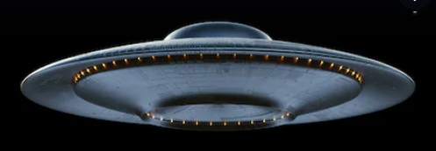

Once we’ve shown we protect against the Asteroid onslaught, the Aliens finally decide to risk attacking the Earth with their mothership.

It moves around the game screen rapidly, has shields and takes many many hits to destroy.

Meanwhile the Aliens are constantly launching attacks that are similar in nature to the previous waves defeated by the Player.

The Player must first defeat each round of attack before they can ‘disable’ the Aliens shield for a short time, enabling them to damage it for a short time.

As the Alien ship gets progressively more damaged, it dodges attacks, uses decoys and strategies to attempt to prevent the Player from damaging it further.

Bonus Material for the game will include features such as achievements for completing the game levels in the fastest times, with a bronze/silver/gold criteria for awards.



Statistics on accuracy can be presented after every level, showing the Player their level of skill.

These awards and statistics will be output to screenshots for the PC players to share on social media. If the game gets created on consoles or mobile devices, the Players achievements can be shared through each platform's respective gaming hub or through the share function on phones.

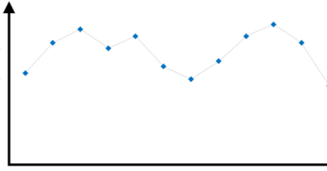

Every time the Player defeats the game, they unlock an increased difficulty mode. This allows Players bragging rights for defeating the game on ‘red’ difficulty etc.

Once the game has been beaten once, the Player can change the sprites for the Asteroids to some selected absurd ones. Cupcakes, kitten heads, Donald Trump are all selectable choices.

The game will be sold for a small amount, based on the simple nature of the gameplay being presented. Players that get stuck repeatedly, will have the option of paying for additional ‘helper’ Power Ups, but will have their achievements and awards suitably marked in a way to show the shortcut taken.

There is the potential for additional game content/levels to be created subsequently and have them available for purchase by the Player.



Merchandise in the form of “I helped defend the planet” t-shirts will be sold.

Resin models of the Planetary Defence Cannon will also be available for purchase.

